Exercice 1
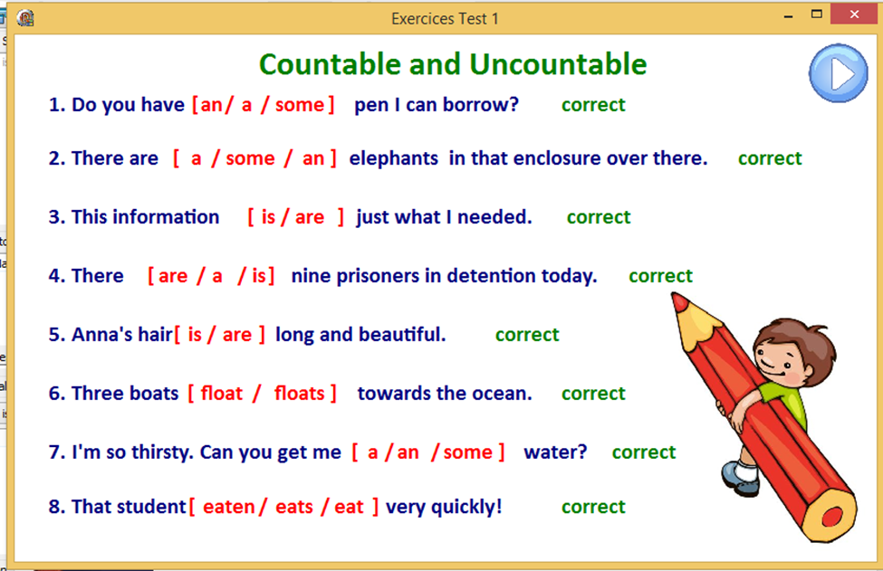
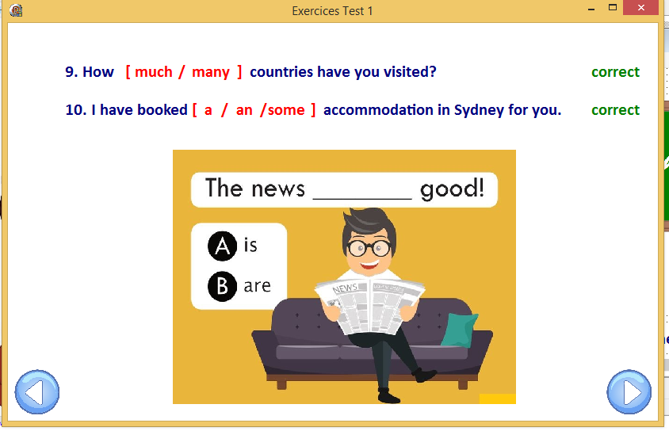
Exercice 2
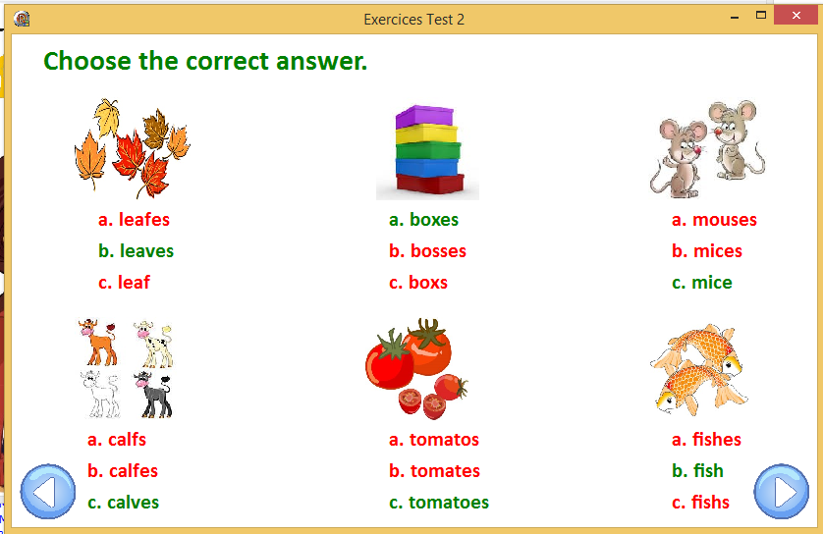
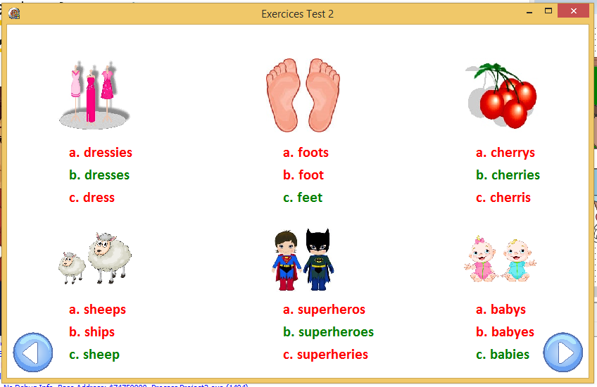
Test 3
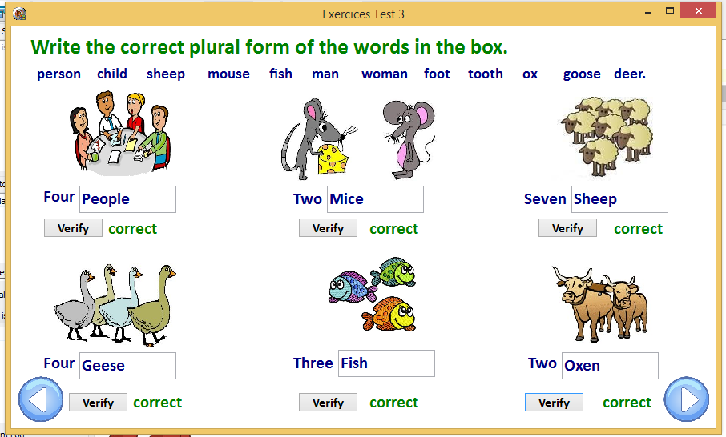
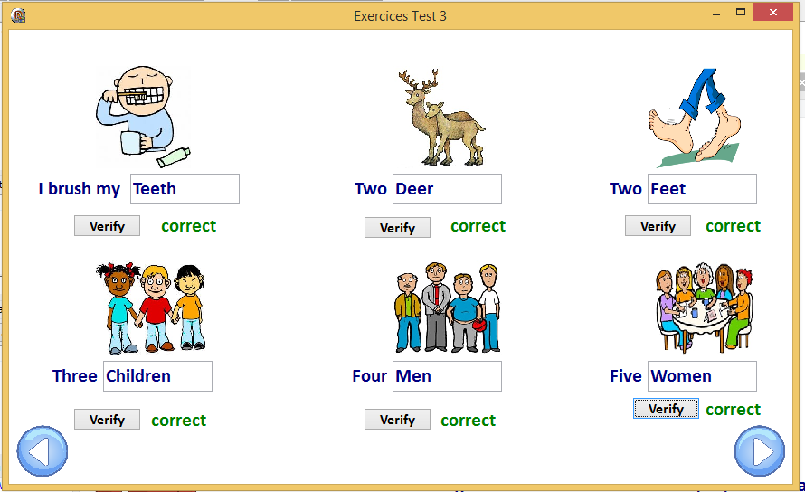

Exercice 4
Identify the Common Nouns in the following sentences. Write on the sentence for the answer:
- They arrived early but at the wrong station.
- We counted only six different colours in the rainbow.
- The man was trying to steal a horse with a cart full of apples.
- My mother is singing a religious song in the kitchen.
- My brother wants to play hide-and-seek with us.

Exercice 1 Gender
Change the nouns in bold from the feminine/masculine to the masculine/feminine. Click the question for the answer.
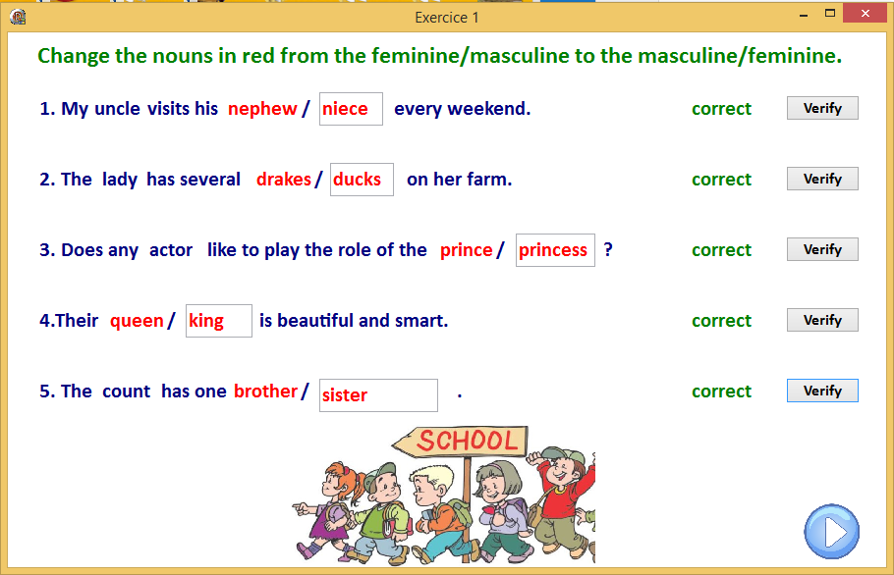

Exercice 2 Gender
Can you put the two together?

